### 

### Semester One Examination, 2023

### Question/Answer booklet

# 12 SPECIALIST MATHEMATICS

## Section One:

## Calculator-free

|  |
| --- |
|  |

Your Name

Your Teacher’s Name

## Time allowed for this section

Reading time before commencing work: five minutes

Working time: fifty minutes

## Materials required/recommended for this section

***To be provided by the supervisor***

This Question/Answer booklet

Formula sheet

***To be provided by the candidate***

Standard items: pens (blue/black preferred), pencils (including coloured), sharpener, correction fluid/tape, eraser, ruler, highlighters

Special items: nil

## Important note to candidates

No other items may be taken into the examination room. It is **your** responsibility to ensure that you do not have any unauthorised material. If you have any unauthorised material with you, hand it to the supervisor **before** reading any further.

|  |  |  |  |  |  |
| --- | --- | --- | --- | --- | --- |
| Question | Mark | Max | Question | Mark | Max |
| 1 |  |  | 5 |  |  |
| 2 |  |  | 6 |  |  |
| 3 |  |  |
| 4 |  |  |

**Structure of this paper**

|  |  |  |  |  |  |
| --- | --- | --- | --- | --- | --- |
| Section | Number of questions available | Number of questions to be answered | Working time (minutes) | Marks available | Percentage of examination |
| Section One:  Calculator-free | 6 | 6 | 50 | 50 | 34 |
| Section Two:  Calculator-assumed | 12 | 12 | 100 | 97 | 66 |
|  |  |  |  | **Total** | 100 |

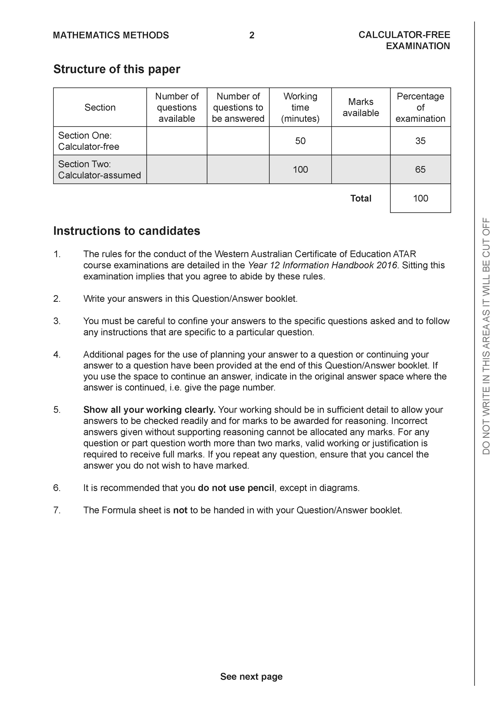

**Section One: Calculator-free (50 Marks)**

This section has **seven (7)** questions. Answer **all** questions. Write your answers in the spaces provided.

Spare pages are included at the end of this booklet. They can be used for planning your responses and/or as additional space if required to continue an answer.

● Planning: If you use the spare pages for planning, indicate this clearly at the top of the page.

● Continuing an answer: If you need to use the space to continue an answer, indicate in the original answer space where the answer is continued, i.e. give the page number. Fill in the number of the question that you are continuing to answer at the top of the page.

Working time: 50 minutes.

**Question 1 (8 marks)**

Consider the functions  and .

1. Determine the natural domain and range of . (2 marks)

|  |
| --- |
| **c** |
|  |
| **Specific behaviours** |
| P states domain  P states range |

1. Does  exist over the natural domain of ? Explain. (3 marks)

|  |
| --- |
| **c** |
| Therefore does not exist over natural domain. |
| **Specific behaviours** |
| P states condition needed to exist  P states required domain and range  P concludes that does not exist. |

1. Determine  and its natural domain. (3 marks)

|  |
| --- |
| **c** |
|  |
| **Specific behaviours** |
| P obtains an expression for function  P simplifies as shown above  P states domain |

**Question 2 (8 marks)**

Consider then function  which is graphed below.

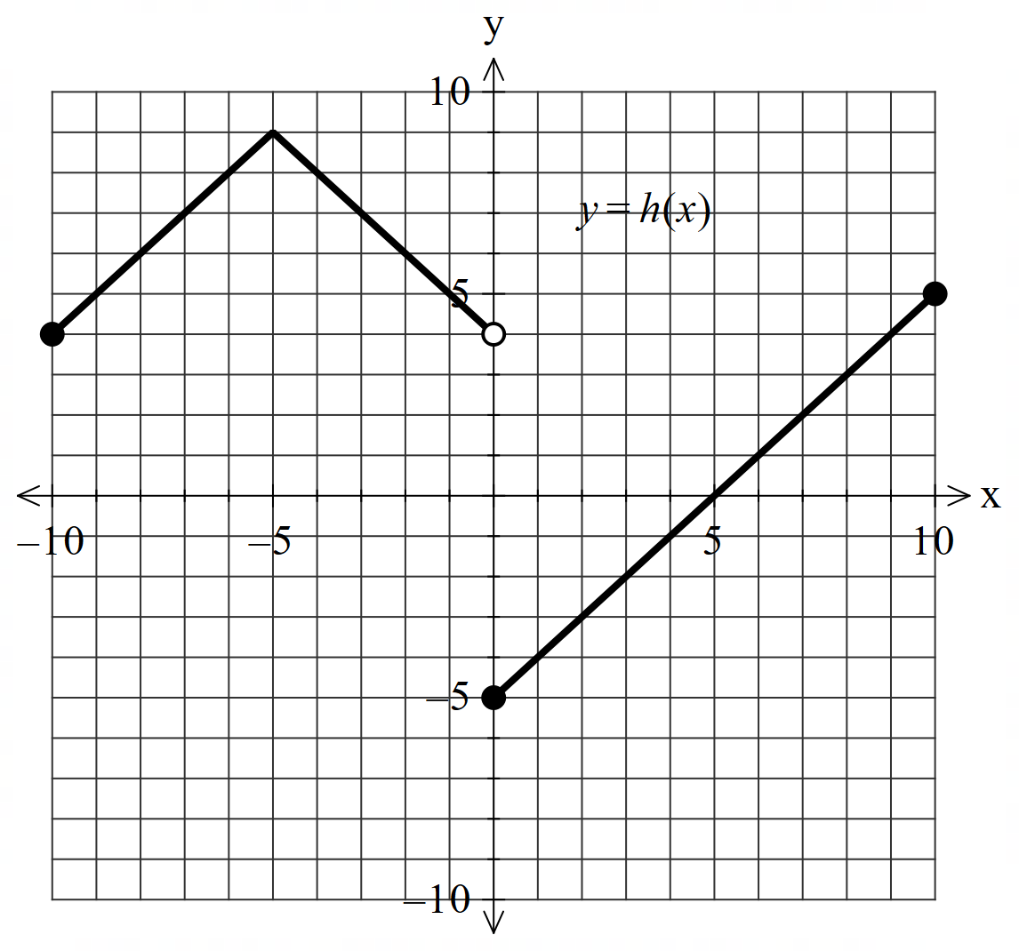

1. Solve for . (2 marks)

|  |
| --- |
| **c** |
|  |
| **Specific behaviours** |
| P states two correct values of x  P states all values only |

1. Sketch  on the axes below. (3 marks)

|  |
| --- |
| **c** |
|  |
| **Specific behaviours** |
| P uses left side to give new right side  P open hole on y axis at y=4  P shape |

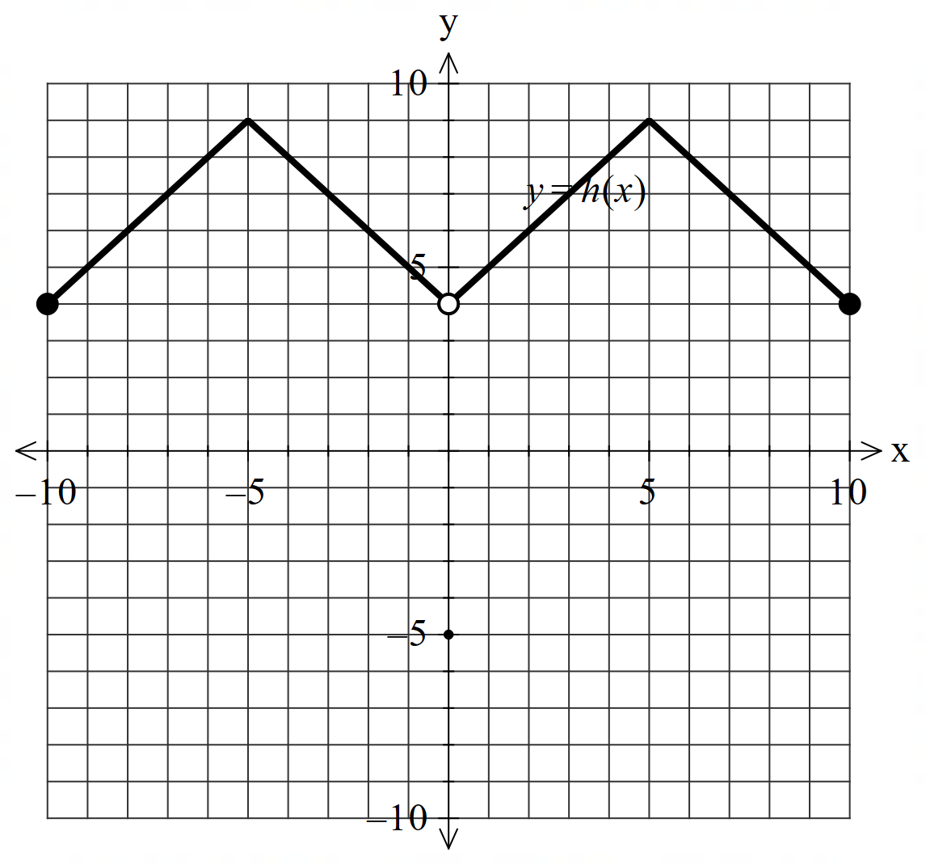

1. Sketch  on the axes below. (3 marks)

|  |
| --- |
| **c** |
|  |
| **Specific behaviours** |
| P asymptote at x=5  P correct limits for y intercept , left open and right closed  P correct shape |

**Question 3 (8 marks)**

Consider the following planes:



1. Show that none of these planes are parallel. (2 marks)

|  |
| --- |
| **c** |
| Three normal vectors  are not parallel to each other. |
| **Specific behaviours** |
| P states all 3 normal vectors  P states that the vectors are not parallel |

1. Solve the system of simultaneous equations. (3 marks)

|  |
| --- |
| **c** |
|  |
| **Specific behaviours** |
| P eliminates one variable from an equation  P eliminates two variables from the one equation  P states all 3 variables |

1. Consider the system of equations below with  being constants.

(3 marks)



Determine all possible values of such that there are:

1. No solutions.
2. Infinite solutions.
3. A unique solution.

|  |
| --- |
| **c** |
|  |
| **Specific behaviours** |
| P obtains a line with two zeros  P states values for uniqueness  P state values for infinite and no solns |

**Question 4 (7 marks)**

Consider the three complex numbers plotted below in the Argand diagram.

1. Determine the complex number  in exact cartesian form. (2 marks)

|  |
| --- |
|  |
|  |
| **Specific behaviours** |
| P converts to polar  P converts to exact cartesian |

1. Plot the complex number  on the axes above. (2 marks)

|  |
| --- |
| **c** |
|  |
| **Specific behaviours** |
| P correct argument  P modulus of near 1 unit |

1. State the modulus and argument of . (3 marks)

|  |
| --- |
|  |
|  |
| **Specific behaviours** |
| P converts to polar form for each value  P states modulus, un-simplified  P states argument un-simplified |

**Question 5 (10 marks)**

Consider the function  which is graphed below.

1. On the axes above, plot . (2 marks)

|  |
| --- |
| **c** |
|  |
| **Specific behaviours** |
| P point (1,1) shown on inverse  P appears to be reflected in line y=x |

1. Determine the rule for  and state its domain. (3 marks)

|  |
| --- |
| **c** |
|  |
| **Specific behaviours** |
| P swaps x and y and solves for y  P discards positive value and chooses negative  P states domain and rule |

Consider the function  where  is a positive constant.

1. Does  have an inverse function? Explain. (2 marks)

|  |
| --- |
| **c** |
| As function is a one to one it does have an inverse |
| **Specific behaviours** |
| P states yes with a reason  P states that function is one to one |

1. Determine the x values in terms of  for where . (3 marks)

|  |
| --- |
| **c** |
|  |
| **Specific behaviours** |
| P equates to x  P states one value in terms of a  P states two values in terms of a and zero |

**Question 6 (9 marks)**

The Argand diagram below shows a right-angled triangle , with semicircle centred at .

<EFOFEX>

id:fxd{464e33fe-6a27-4b09-9973-827da3eac656}


FXData:


</EFOFEX>

(a) Given represents the complex number , determine the complex number  
representing . (1 mark)

|  |
| --- |
| **c** |
|  |
| **Specific behaviours** |
| PStates in rectangular form. |

(b) State the locus of points that define semicircle . (3 marks)

|  |
| --- |
|  |
|  |
| **Specific behaviours** |
| P Translates by loci right 1 unit.   * States locus representing circle.   P States locus restricting the argument. |

The rays and form angles of with the positive direction of the real axis.

Let be the complex number , and be the complex number .

(c) Determine, in polar form, . (3 marks)

|  |
| --- |
|  |
|  |
| **Specific behaviours** |
| * Determines . * Uses cosine rule to determine the modulus.   P Determines argument of and states in polar form. |

(d) Explain why . (2 marks)

|  |  |
| --- | --- |
| **Solution** | **Specific behaviours** |
|  | * States that . * States that is rotated clockwise. |

**End of section one**

**Working out space.**

Working out space.